Day 2 Lab

Q.1 create a yaml for deploying webserver that whenever the content chnages then only then service will start otherwise not.

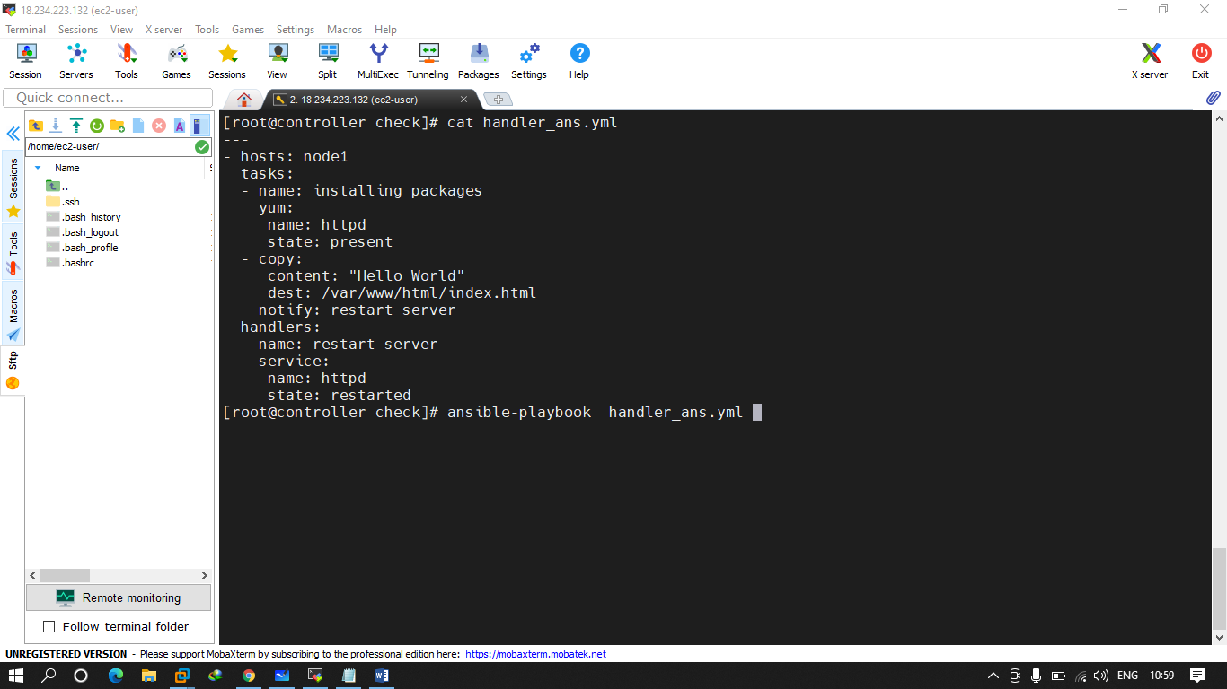

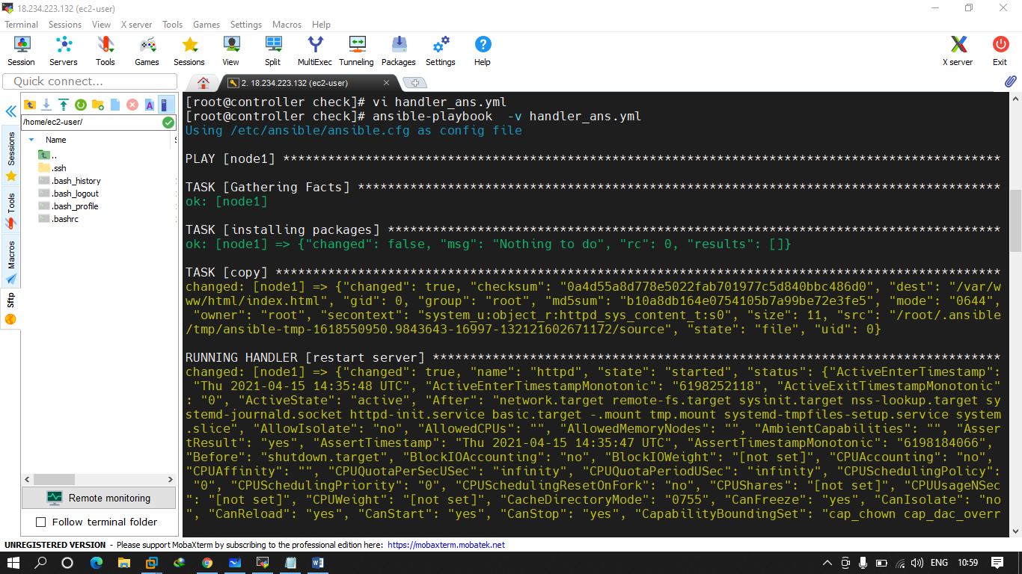

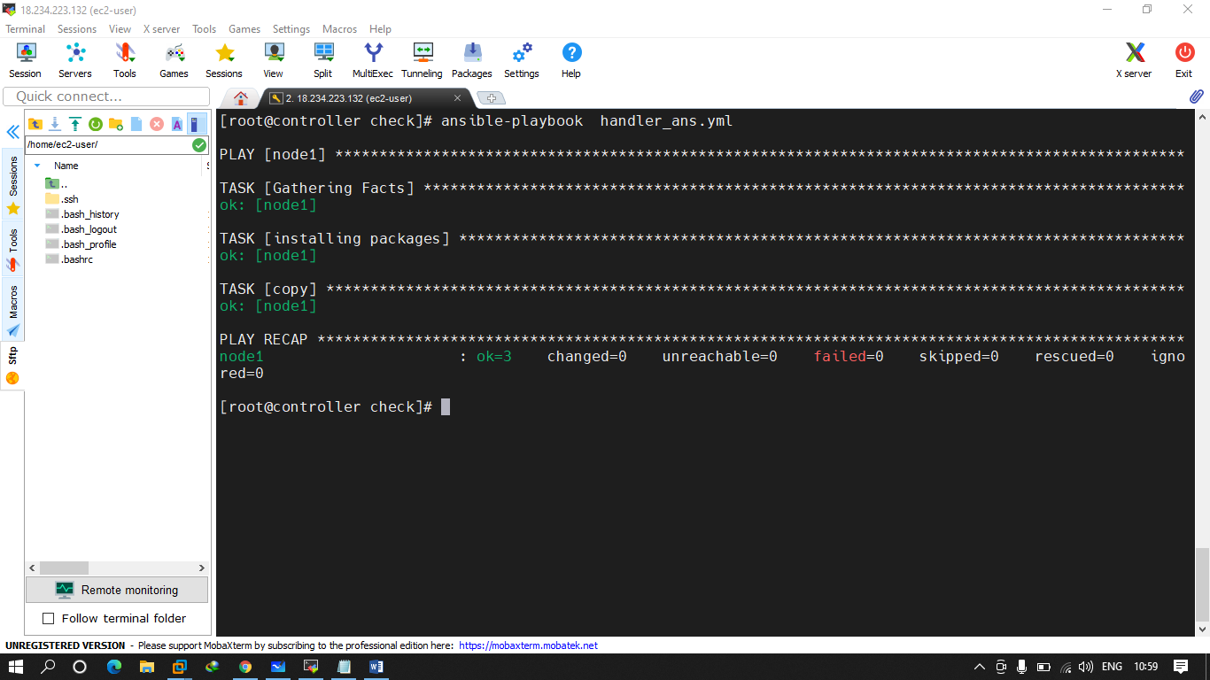

Q.2 try to create file on everymachine with name of ansible.txt but one file sholud be created in ur ansible server with content “Ansible Delegation ”

And in another machines content should be different.

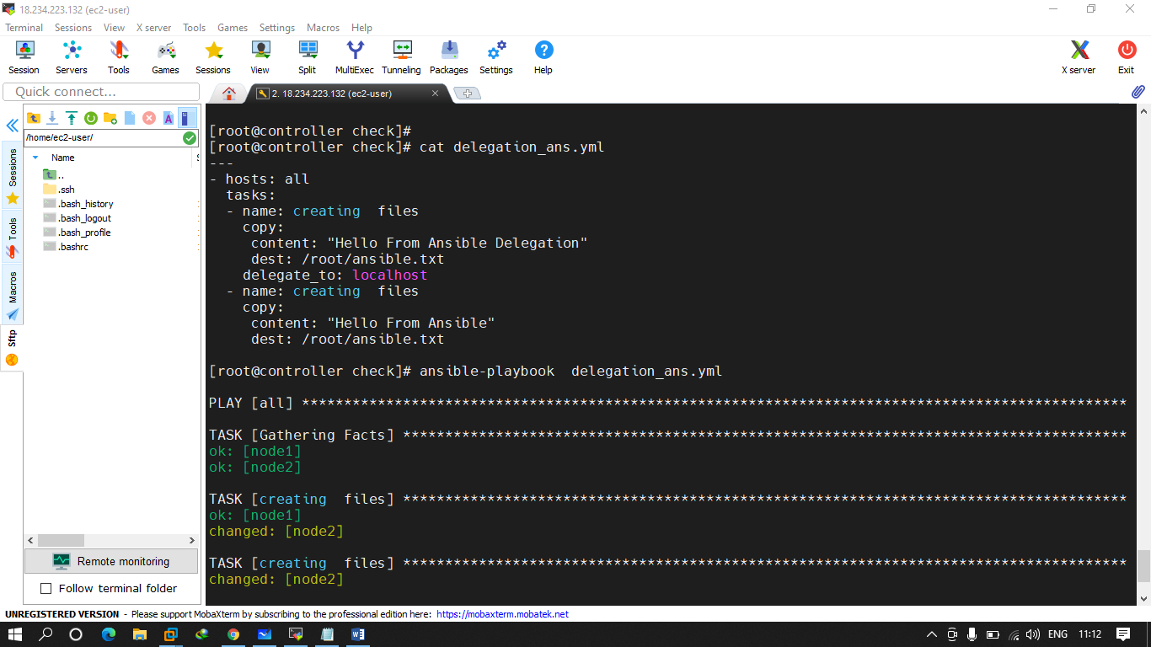

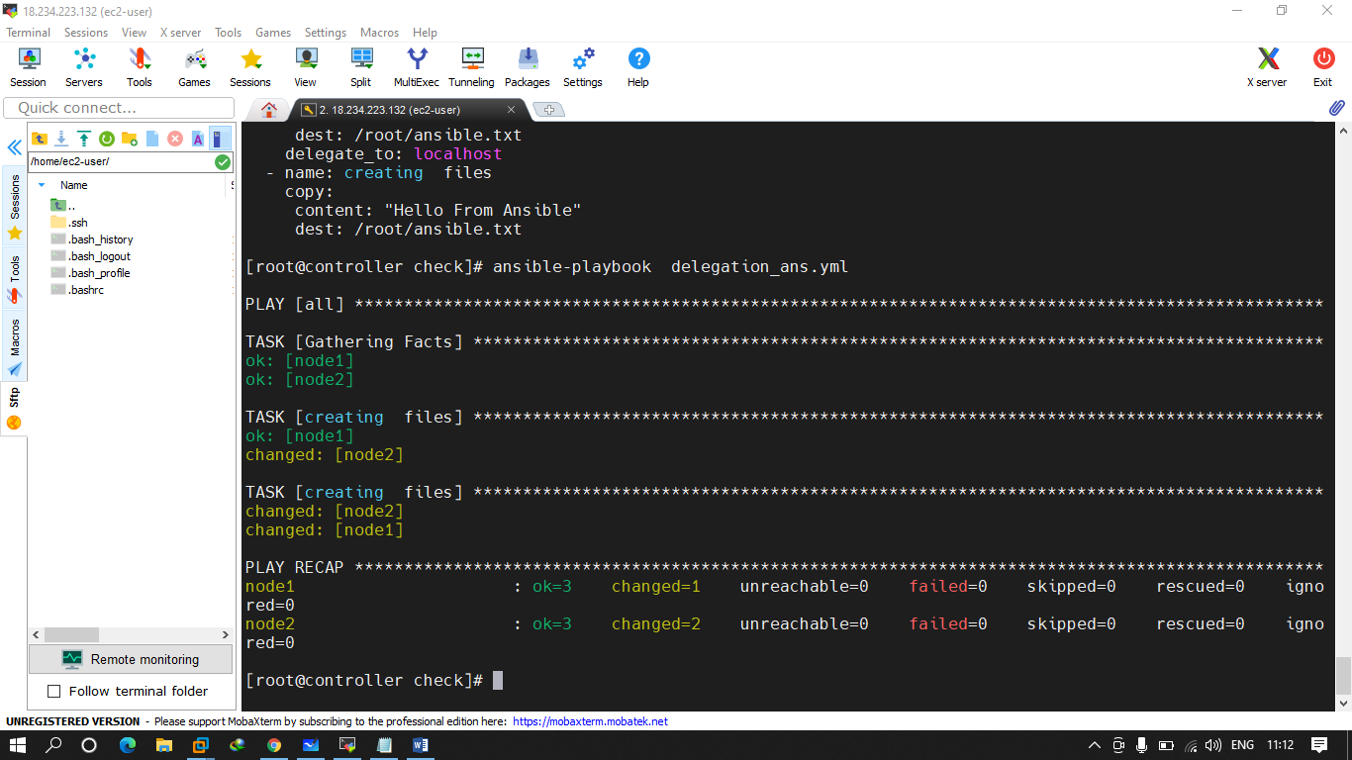

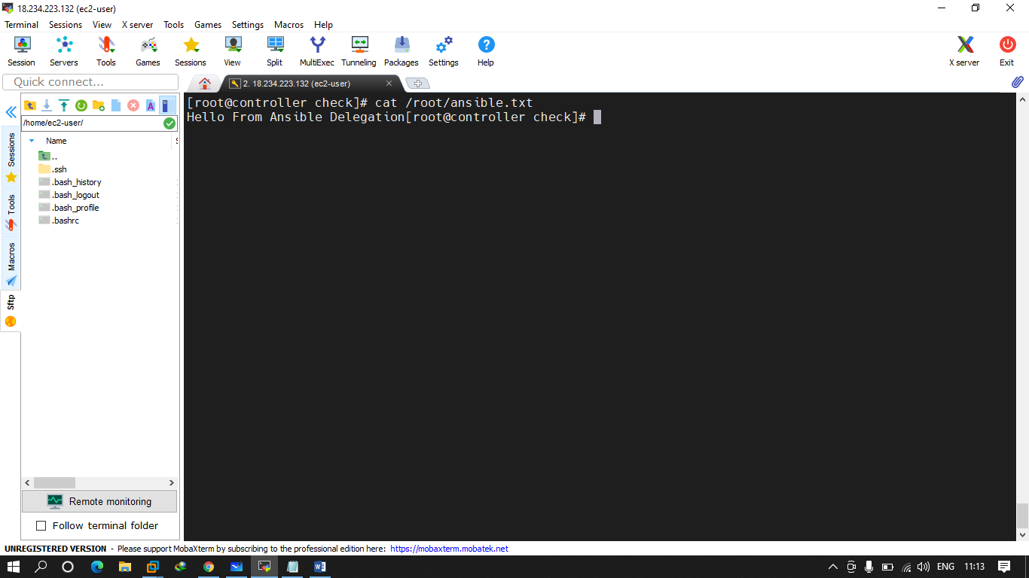

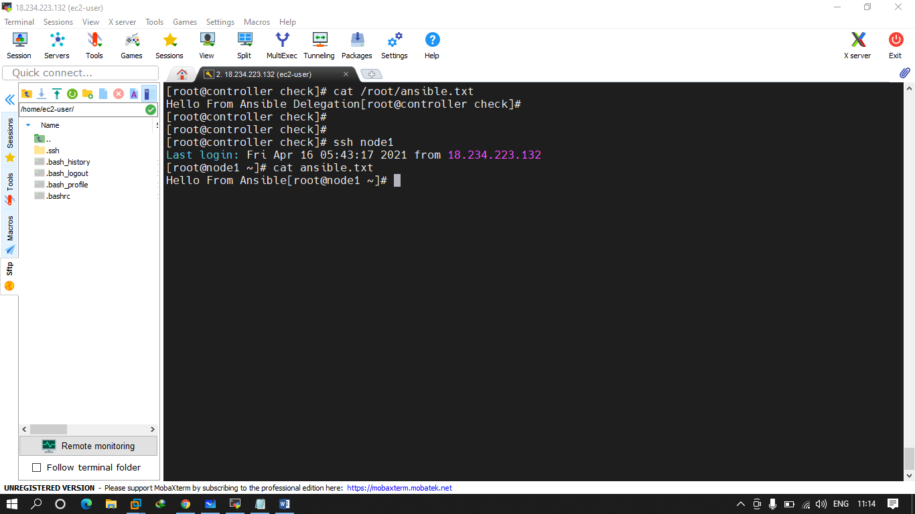

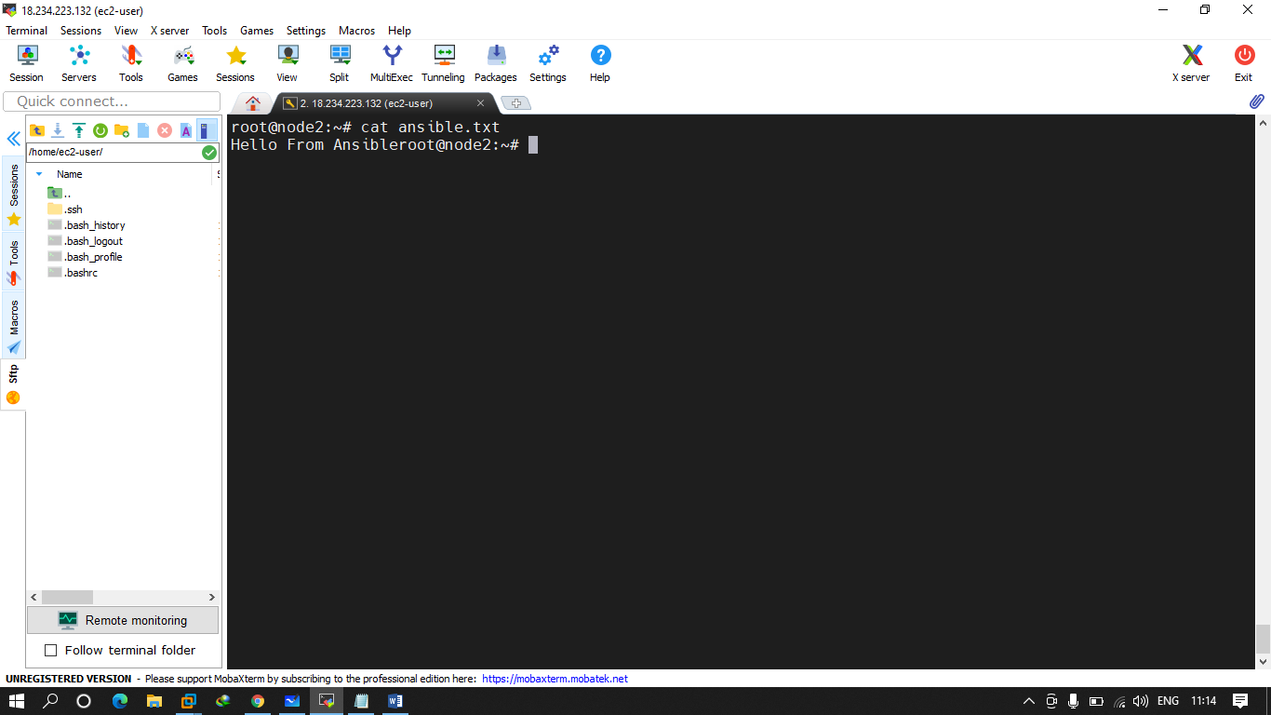

Q.3 create a playbook that will use free strategy and with forks value 3 only. And try to run this playbook one at a time.

Task -- print the msg – Hello from strategy

Try to run a command whoami .

Ans.

Vim /etc/ansible/ansible.cfg - and change the value of fork to 3

